HOW TO TRACK AND SEE POD IN TCS

TCS
STEP - 1:
Go TCS website - http://client.shreetirupaticourier.net/w_custlogin.aspx
Username - 6354788
Password – TAOS
STEP – 2:
Paste the tracking id in the arrow mark. Then press document tracking.
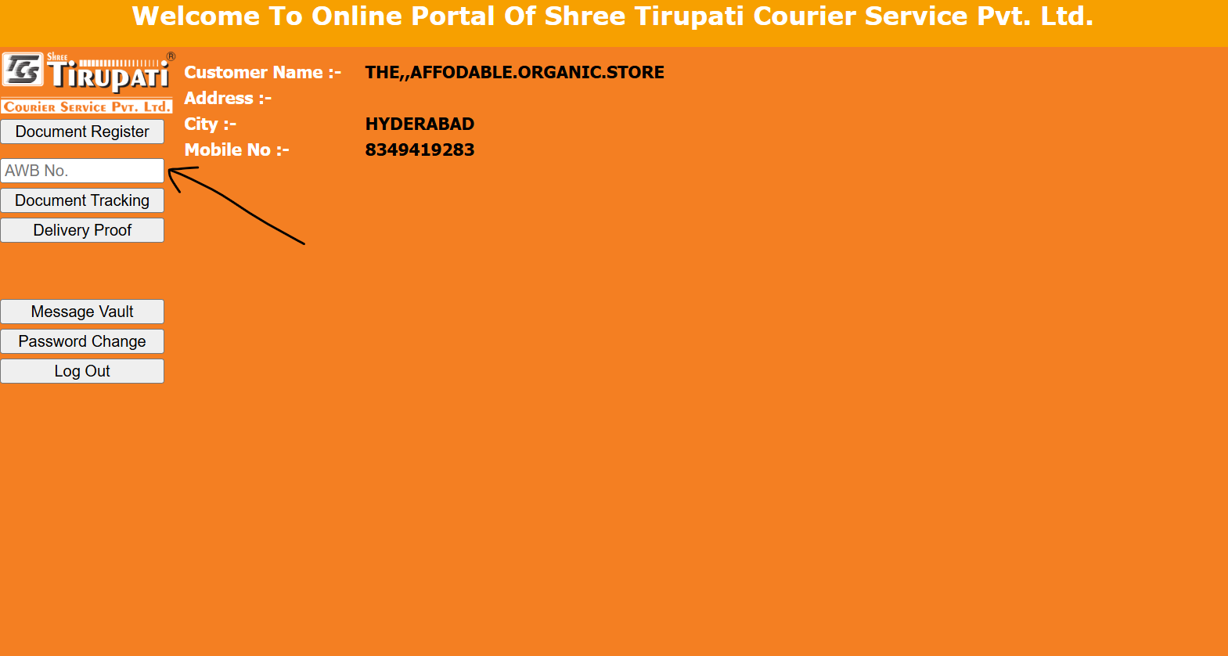

STEP – 3:
Latest update along with contact numbers will appear. In case of any query, call to that contact number.
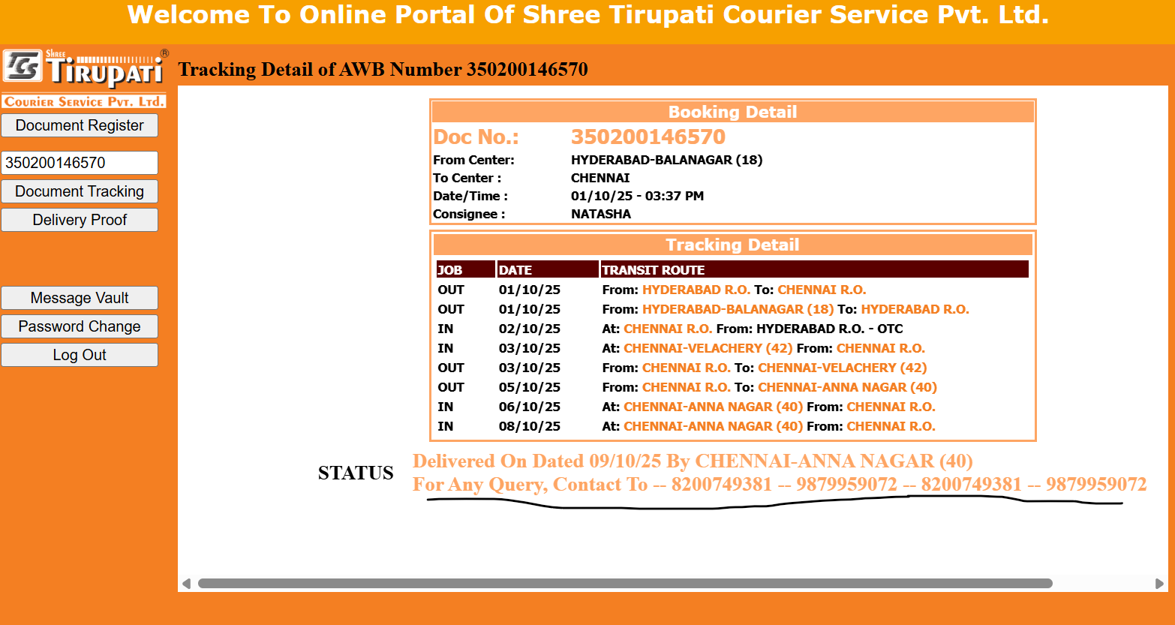
STEP – 4:
If POD is needed, click on delivery proof and match the tracking number.
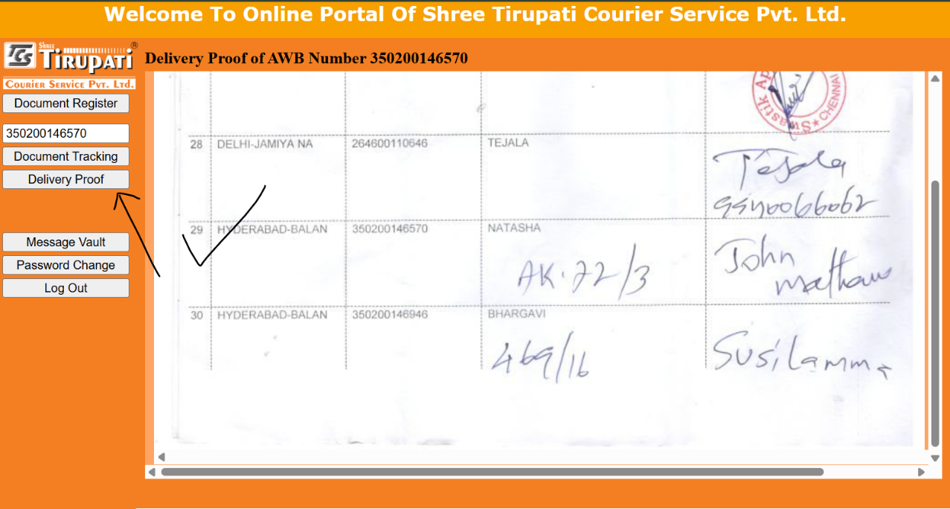
STEP – 5:
For raising ticket, go to message vault, then new message. Type issue with AWB no. mentioned.
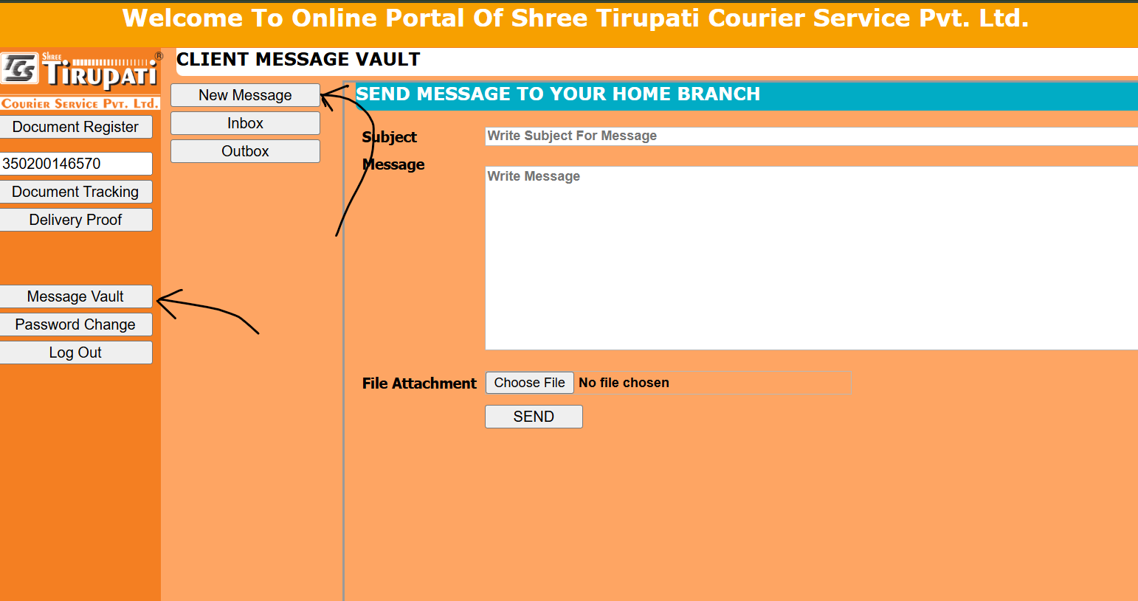

**For TCS, if sometimes POD is not found or ticket raise is needed, there is a dedicated whatsapp group of TCS where problems can be escalated mentioning AWB no. If within 2 days, no responses come, reship is done with another courier partner**

